COMPUTER Network Design Assessment
Private and Public Network Segmentation using Cisco Packet Tracer
CO4_AT3:
Name: S. Hari Prasath Register No: 192512041

1. Aim:
To design a small enterprise network in Cisco Packet Tracer consisting of a public client network and a private client network, and to configure the network so that the private client network can reach its own dedicated web server while being restricted from accessing the public web server.

2. Network Topology:
The network was built using four switches, one router, two servers, and four PC end devices, arranged as shown below.
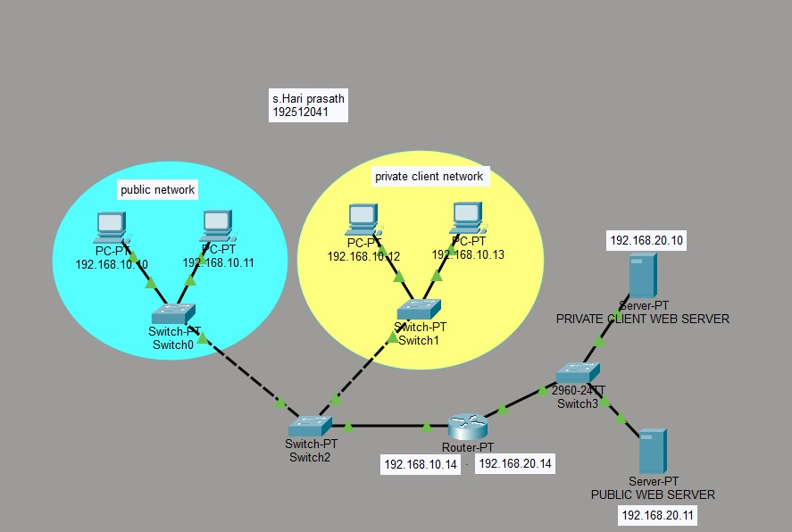
Figure 1: Logical Topology

2.1 Devices Used:
- Switch0, Switch1 - access switches for the public and private client networks
- Switch2, Switch3 (2960-24TT) - distribution switches connecting the router to the LANs and to the servers
- Router-PT - performs inter-network routing between the client subnet and the server subnet
- PC0, PC1 - hosts in the public network
- PC2, PC3 - hosts in the private client network
- Server-PT (Private Client Web Server) and Server-PT (Public Web Server)

3. IP Addressing Scheme:
Device | Network | IP Address
PC0 | Public network | 192.168.10.10
PC1 | Public network | 192.168.10.11
PC2 | Private client network | 192.168.10.12
PC3 | Private client network | 192.168.10.13
Router-PT (client-side interface) | 192.168.10.0/24 | 192.168.10.14
Router-PT (server-side interface) | 192.168.20.0/24 | 192.168.20.14
Private Client Web Server | 192.168.20.0/24 | 192.168.20.10
Public Web Server | 192.168.20.0/24 | 192.168.20.11

4. Design Objective:
The private client network (PC2 and PC3) is intended to have access only to the Private Client Web Server (192.168.20.10). Access from the private client network to the Public Web Server (192.168.20.11) should be denied, so that the two servers remain logically separated even though both sit on the same 192.168.20.0/24 segment.

5. Testing and Verification:
Connectivity was verified from both hosts in the private client network using the ping command.

5.1 Ping Test from PC3 (192.168.10.13):
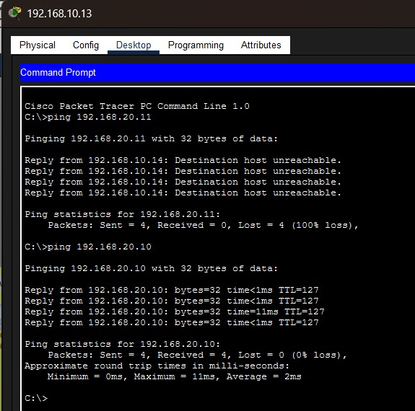
Figure 2: Ping results from PC3
- Ping to 192.168.20.11 (Public Web Server): all 4 packets returned "Destination host unreachable" from 192.168.10.14 - 100% loss.
- Ping to 192.168.20.10 (Private Client Web Server): all 4 packets replied successfully - 0% loss, average round trip time about 2 ms.

5.2 Ping Test from PC2 (192.168.10.12):
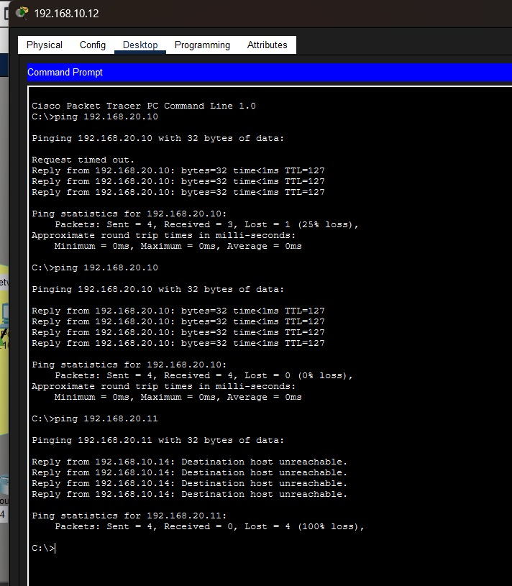
Figure 3: Ping results from PC2
- First ping to 192.168.20.10: one request timed out (ARP resolution delay), remaining 3 replies successful - 25% loss.
- Second ping to 192.168.20.10: all 4 packets replied successfully - 0% loss.
- Ping to 192.168.20.11 (Public Web Server): all 4 packets returned "Destination host unreachable" from 192.168.10.14 - 100% loss.

6. Result:
Both PC2 and PC3 in the private client network were able to successfully reach the Private Client Web Server (192.168.20.10) with 0% packet loss on repeated testing. Both hosts were unable to reach the Public Web Server (192.168.20.11); the router at 192.168.10.14 responded with "Destination host unreachable" for every attempt. This confirms that the private client network has connectivity only to its designated server and is correctly restricted from the public web server, meeting the design objective stated in Section 4.

